|  |  |  |
| --- | --- | --- |
| **#** | **name** | **ID** |
| **1** | **Ahmed Sayed Hassan Youssef** | **20190034** |
| **2** | **Khaled Ashraf Hanafy Mahmoud** | **20190186** |
| **3** | **Aya-tullah Essam-el dein Mohamed** | **20190123** |
| **4** | **Samah Mostafa Hussein** | **20190248** |

**Project Name**

**University Relationships Hierarchy**

**Definition of the problem**

**Define an ontology for a university. Clearly distinguish**

**individuals from classes and the subclass and others' relationships.**

**Design of the proposed solution**

**Graphical user Interface**

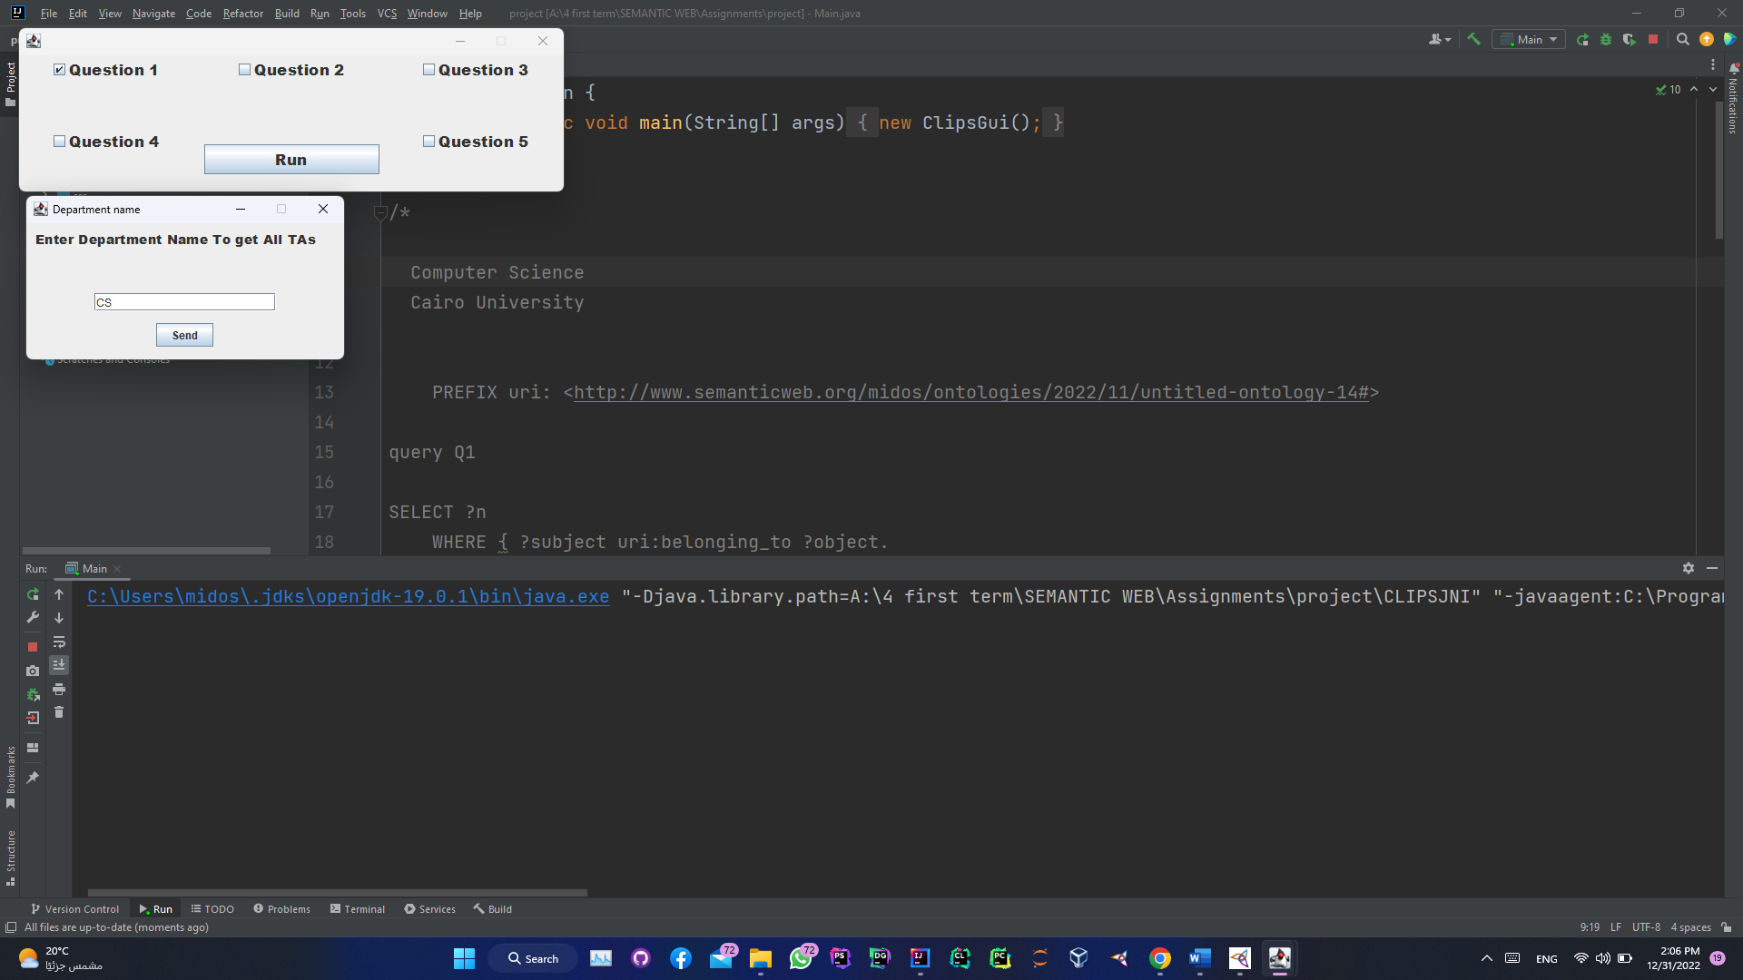

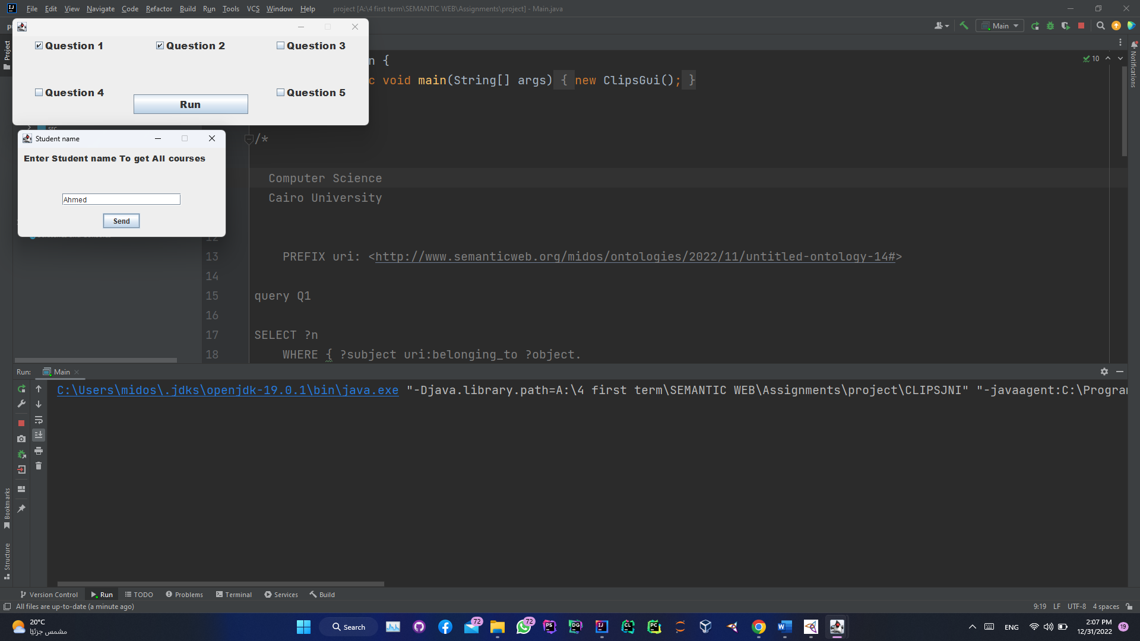

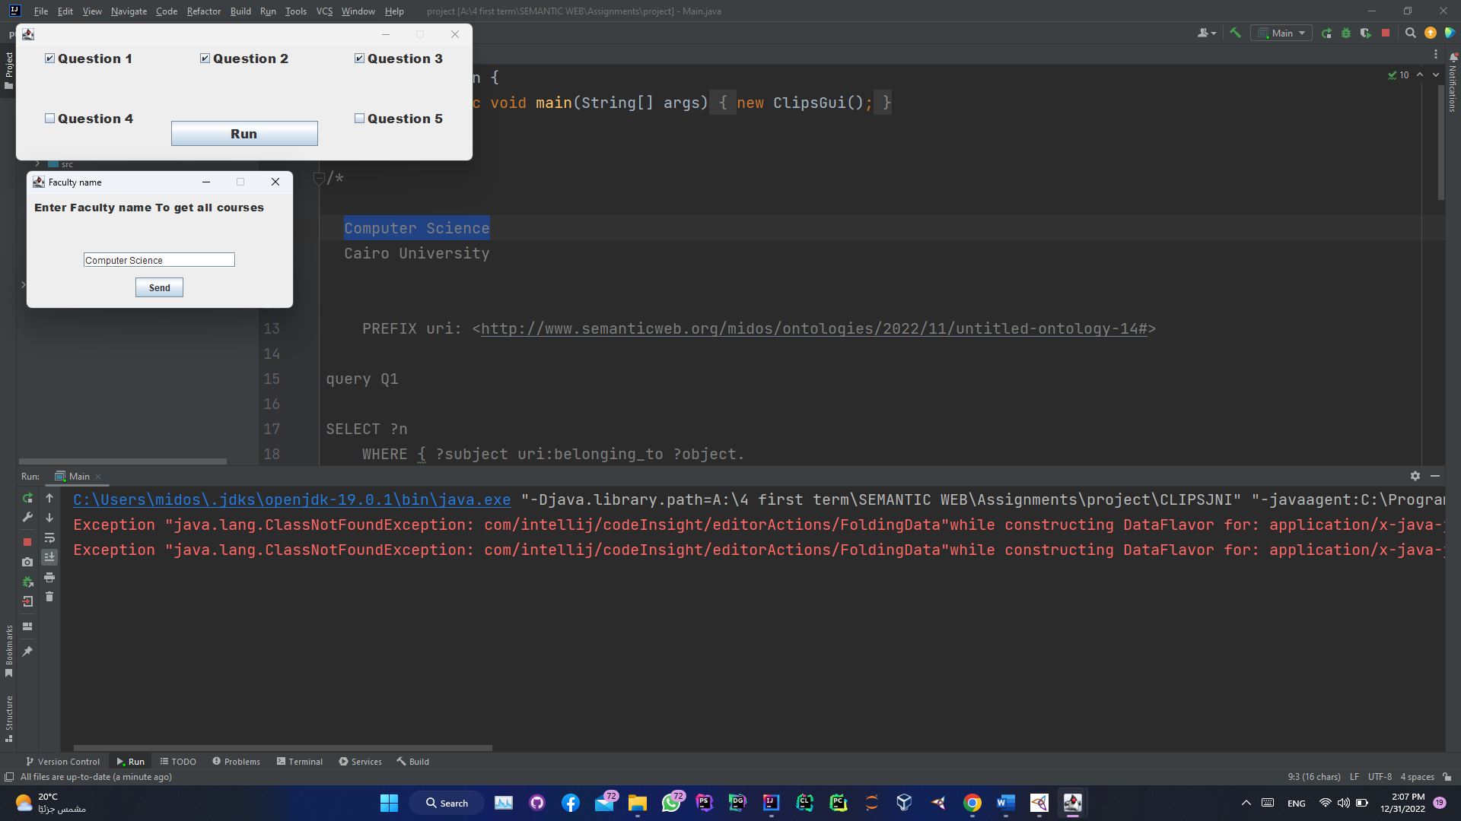

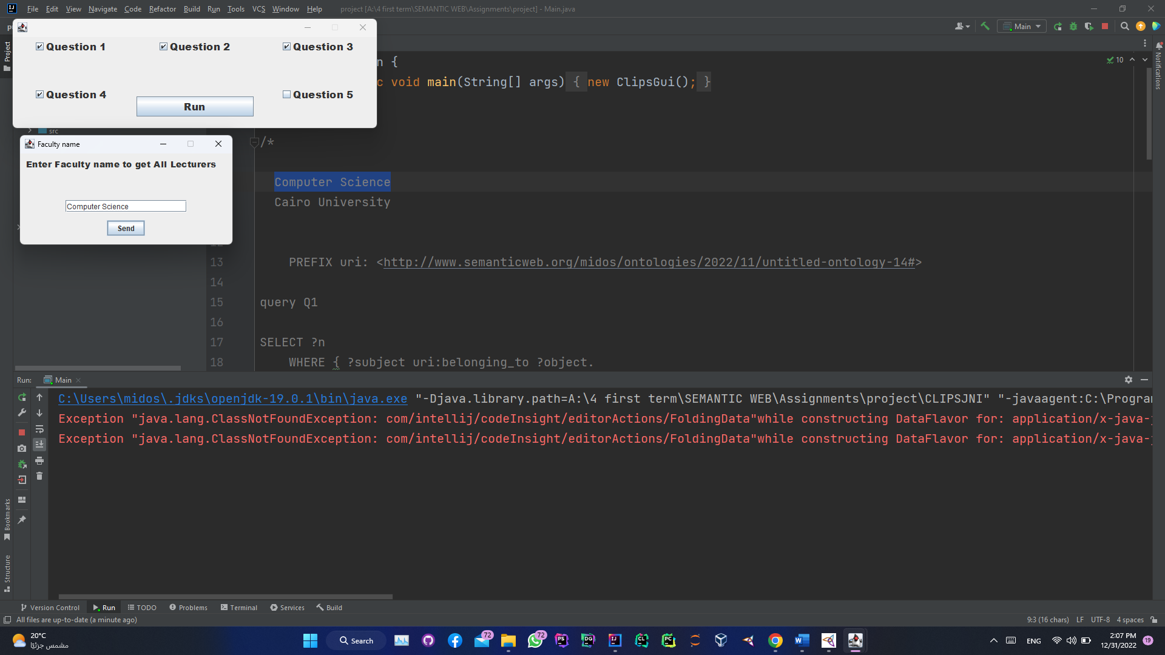

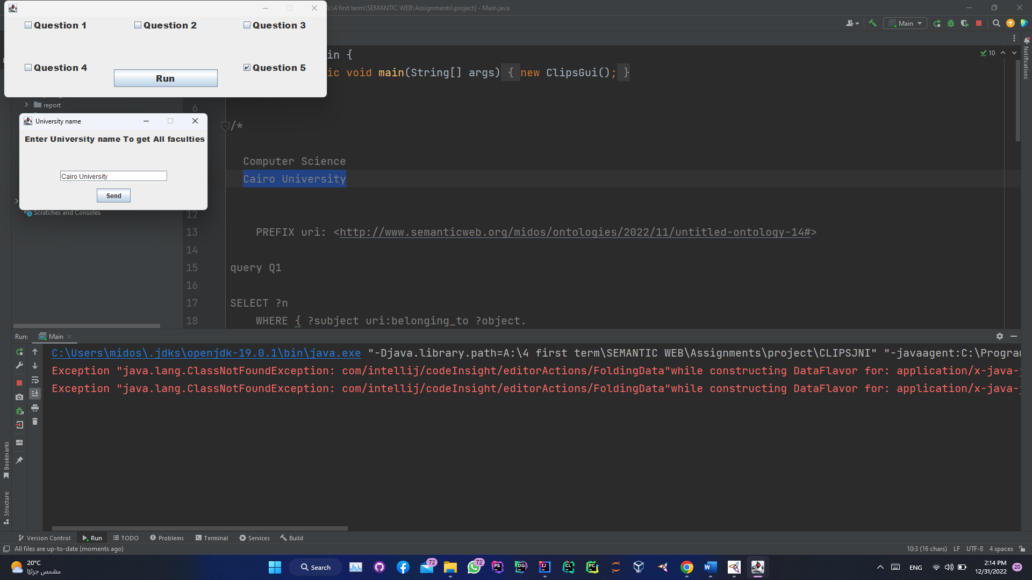

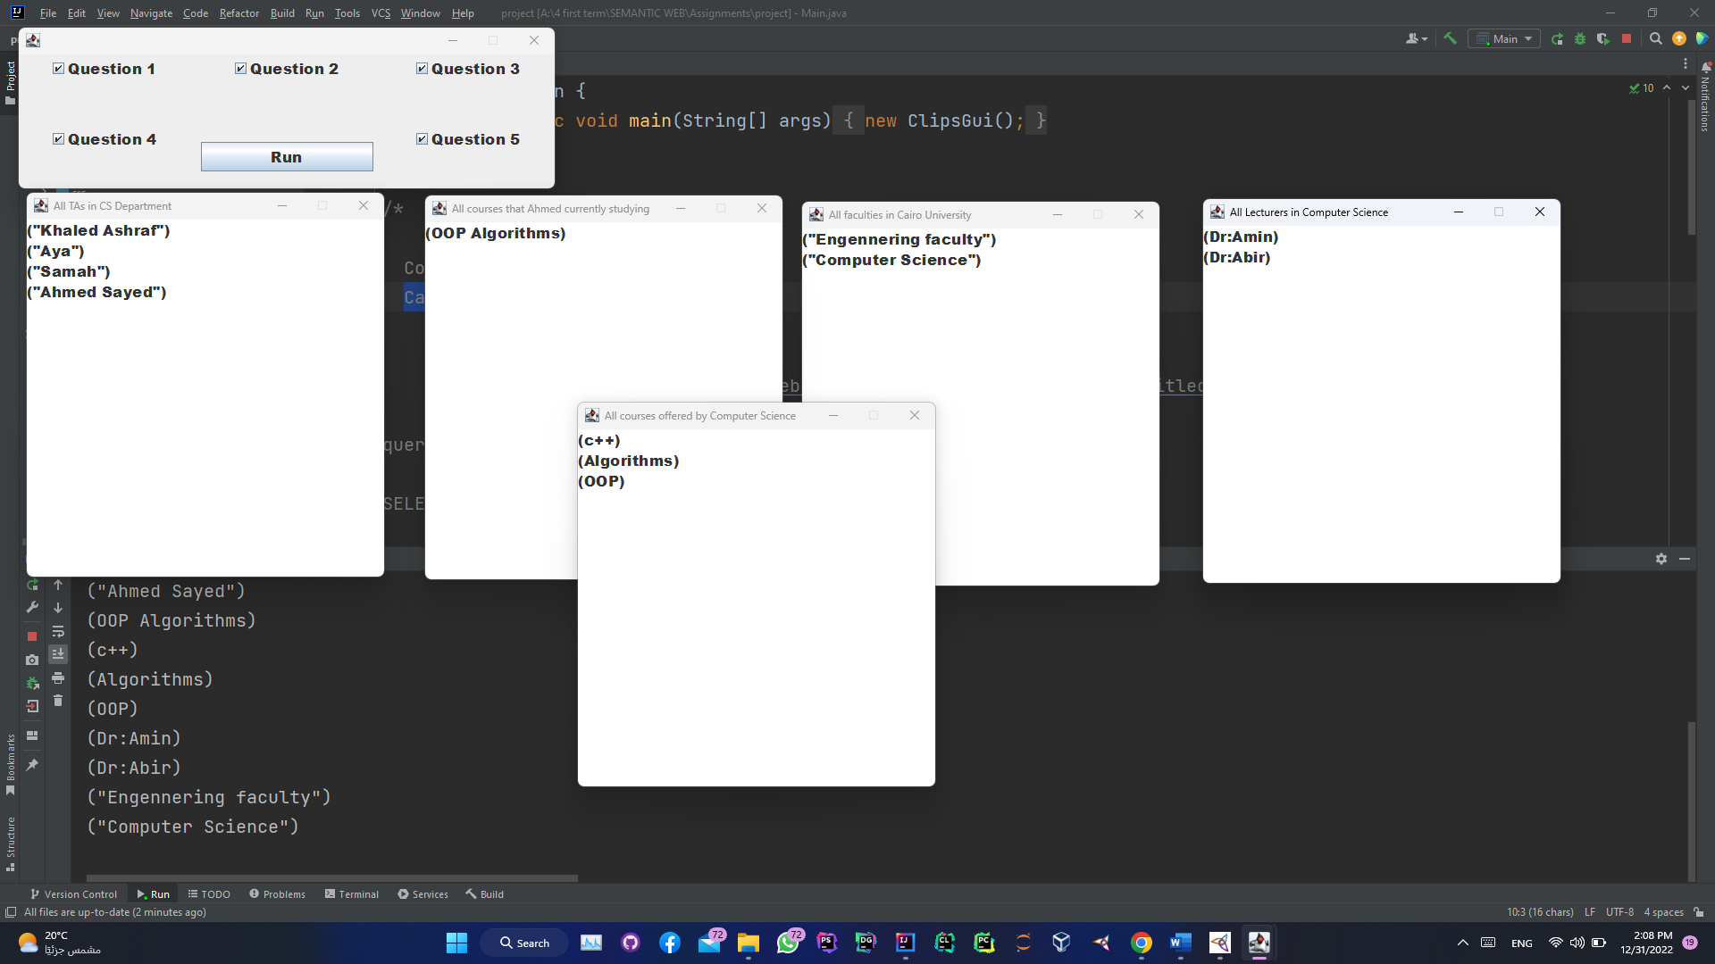**Output GUI**